A tutorial on ELAN: Representing the Sens-Ex Corpus
Following tutorial v2 on exploring the pilot corpus of the Sens-Ex project, this document is designed to guide you in the collaborative work of building Corpus.
For a complete tutorial or for more detailed functionalities and information about the tool, please refer to The Language Archive website: https://archive.mpi.nl/tla/elan
The goal of this tutorial is to help you get a grip on ELAN and gain a solid understating of the data representation protocol for the collected multimedia data. To do so, examples from both the French module of Corpus 1.0 and pilot corpus (Corpus 0) are used.

How to run ELAN

Download ELAN
The first step is to download ELAN, available from The Language Archive website: https://archive.mpi.nl/tla/elan/download
After installing ELAN on your working environment, open the application. You will see a window as shown in the screenshot below.
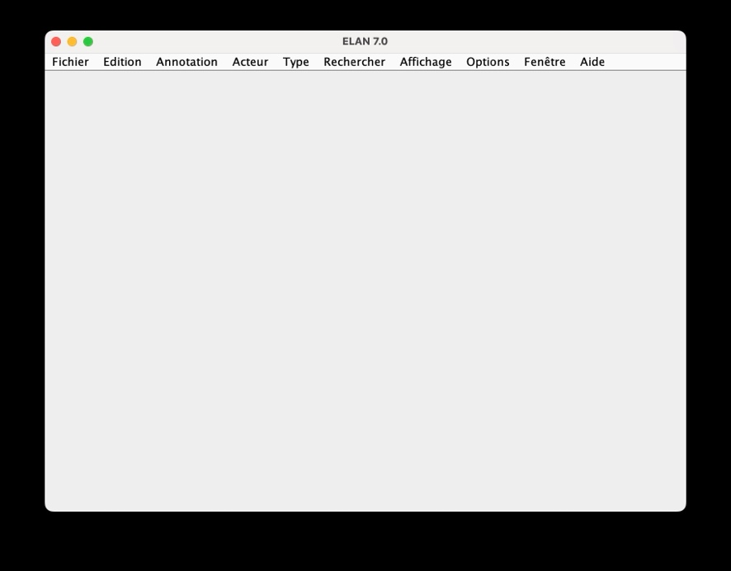
In the menu bar, click Fichiers (‘Files’).
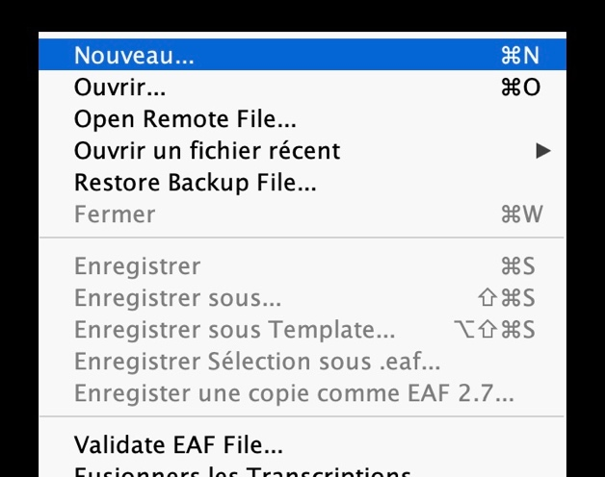
To explore an existing corpus, click Ouvrir (‘Open’).
To create a new annotation, click Nouveau (‘New’).

_Corpus_SensEx_1.0
Before going through the essential functionalities of the tool, let us briefly introduce the organization of Corpus 1.0, as Corpus 2.0 is expected to follow a similar structure.

Organization
The new data were collected with the participation of Ariane Robert, Luisa Troncone, Lelia Pasquetti, Sangwan Jeon, and Paola Pietrandrea.
The collection _Corpus_SensEx_1.0 includes 49 newly collected video stimuli extracted from various CMC platforms (YouTube, TikTok, Twitch, Twitter/X), with particular attention paid to ensuring a variety of speech genres, speakers, and topics.
Corpus 1.0 is composed of two language modules:
- French (25 new stimuli + 30 pilot corpus stimuli); this module also contains data from the pilot corpus.
- Italian (24 new stimuli).

Two modules are structured as follows:
_Corpus_SensEx_1.0/
fr/
0.0_Donnees-annotees-avec-les-resultats-de-lenquete-et-pendant-non-excessif/
fr-exc-youtube-comedic-artus-a/
fr-exc-youtbue-comedic-danyboon/
fr-exc-youtube-influencer-domiyani/
fr-nexc-youtube-influencer-fabiancr-maevaghennam/
fr-nexc-youtube-influencer-maevaghennam-ext19sec/
fr-nexc-youtube-influencer-sananas-a/
fr-nexc-youtube-influencer-sananas-b/
fr-exc-youtube-influencer-sarahfraisou/
fr-exc-tiktok-comedic-thomasangelvy-ext63sec/
fr-exc-youtube-influencer-tiboinshape/
0.1_Autres-donnees-excessives-tirees-du-corpus-pilote/
fr-exc-youtube-comedic-ahmedsylla/
fr-exc-youtube-talk-arnaudjerome/
fr-exc-youtube-comedic-artus-b/
fr-exc-youtube-influencer-fabiancr-nars/
fr-exc-youtube-influencer-fabiancr-maevaghennam/
fr-exc-tiktok-influencer-maevaghennam/
fr-exc-youtube-influencer-maevaghennam-ext22sec/
fr-exc-youtube-influencer-maevaghennam-ext43sec/
fr-exc-tiktok-comedic-thomasangelvy-ext91sec/
0.2_Autres-donnees-non-excessives-tirees-du-corpus-pilote/
fr-nexc-youtube-comedic-ahmedsylla/
fr-nexc-youtube-talk-arnaudjerome/
fr-nexc-youtube-comedic-artus-c/
fr-nexc-youtube-comedic-artus-d/
fr-nexc-youtube-influencer-fabiancr-nars/
fr-nexc-youtube-comedic-gadelmaleh/
fr-nexc-youtube-comedic-malikbentalha/
fr-nexc-facebook-influencer-nabillabenattia/
fr-nexc-youtube-comedic-raymonddevos/
fr-nexc-youtube-influencer-sananas-c/
fr-nexc-youtube-influencer-tiboinshape/
1.0_Nouvelles-donnees/
fr-exc-tiktok-aigenerated-storyraven1/
fr-exc-tiktok-aigenerated-sullymax/
fr-exc-tiktok-tiktok-beadubau_off/
fr-exc-tiktok-tiktok-benoit_chevalier/
fr-exc-twitch-streamingdisc-avamind/
fr-exc-twitch-streamingdisc-kamet0/
fr-exc-x-tweet-nonpol-iciazur/
fr-exc-x-tweet-pol-benoithamon/
fr-exc-youtube-vodcast-humainstv/
fr-exc-youtube-vodcast-kyankhojandi-1/
fr-exc-youtube-vodcast-kyankhojandi-2/
fr-exc-youtube-vodcast-kyankhojandi-3/
fr-exc-youtube-vodcast-legendmedia/
fr-exc-youtube-vodcast-lockin/
fr-nexc-tiktok-aigenerated-sullymax/
fr-nexc-tiktok-aigenerated-voixdusage/
fr-nexc-tiktok-tiktok-akamztwenty20/
fr-nexc-tiktok-tvshow-mouloudachour-beadubau/
fr-nexc-twitch-streamingdisc-avamind/
fr-nexc-twitch-streamingdisc-kamet0/
fr-nexc-x-nonpol-webdiffusionsrc/
fr-nexc-x-tweet-pol-emmanuelmacron/
fr-nexc-youtube-influencer-domiyani/
fr-nexc-youtube-vodcast-legendmedia/
fr-nexc-youtube-vodcast-lockin/
it/
1.0_New-Data/
it-exc-tiktok-aigenerated-scemidigitali-1/
it-exc-tiktok-aigenerated-scemidigitali-2/
it-exc-tiktok-influencer-eleonoraarcidiacono/
it-exc-tiktok-influencer-tiktokerid1/
it-exc-tiktok-tiktok-tiktokerid2/
it-exc-tiktok-tiktok-tiktokerid3/
it-exc-twitch-streamingdisc-kurolily/
it-exc-twitch-streamingdisc-tumblurr/
it-exc-x-tweet-nonpol-fawollo13/
it-exc-x-tweet-pol-giorgiameloni/
it-exc-youtube-vodcast-plenary-allessandrobarbero/
it-exc-youtube-vodcast-pulppodcast/
it-nexc-tiktok-aigenerated-babyciccio/
it-nexc-tiktok-aigenerated-vitosfrankai/
it-nexc-tiktok-influencer-eleonoraarcidiacono/
it-nexc-tiktok-influencer-tiktokerid1/
it-nexc-tiktok-tiktok-tiktokerid2/
it-nexc-tiktok-tiktok-tiktokerid3/
it-nexc-twitch-streamingdisc-kurolily/
it-nexc-twitch-streamingdisc-tumblurr/
it-nexc-x-tweet-nonpol-fabio65c/
it-nexc-x-tweet-pol-ellyesse/
it-nexc-youtube-vodcast-plenary-allessandrobarbero/
it-nexc-youtube-vodcast-pulppodcast/

Please note that each stimulus is available in different formats whose filenames are indexed to the stimulus.
The filename indicates:
- Language
- Excessiveness: Whether the stimulus was initially considered excessive or non-excessive
- Diffusion platform: may include Youtube, tiktok, twitch, tiktok
- Genre type: ai-generated, influencer, tiktok, streaming discourse, tweet/x, vodcast, vodcast-plenary, tv show
- User account
- Topic (if necessary)
- Sequence version (if necessary):
  - A number (1, 2, 3…) when several stimuli were produced by the same account
  - A letter (a, b, c…) when more than two stimuli are extracted from a same video content
- Extract time duration in seconds (if necessary): e.g., -ext22sec
Language | Excessiveness | Diffusion platform | Genre type | User account | Topic | Sequence version
fr- / it- | ex- / nex- | platform- | genretype- | accountname- | topic- | 1…

Each stimulus folder contains:
- Media files: MP4 and WAV (mono, 16-bit, 44.1 kHz)
- ELAN- and Praat-related files: EAF and FLAC
- Transcription sub-folder: TXT (tab-separated values)
  - A file with the suffix “-trs” corresponds to the transcription of verbalized speech (_trs tiers and _verbal tiers)
  - A file without the suffix “-trs” corresponds to the transcription of all tiers including _nonverbal tiers
The screenshot below illustrates the structure of the collection.
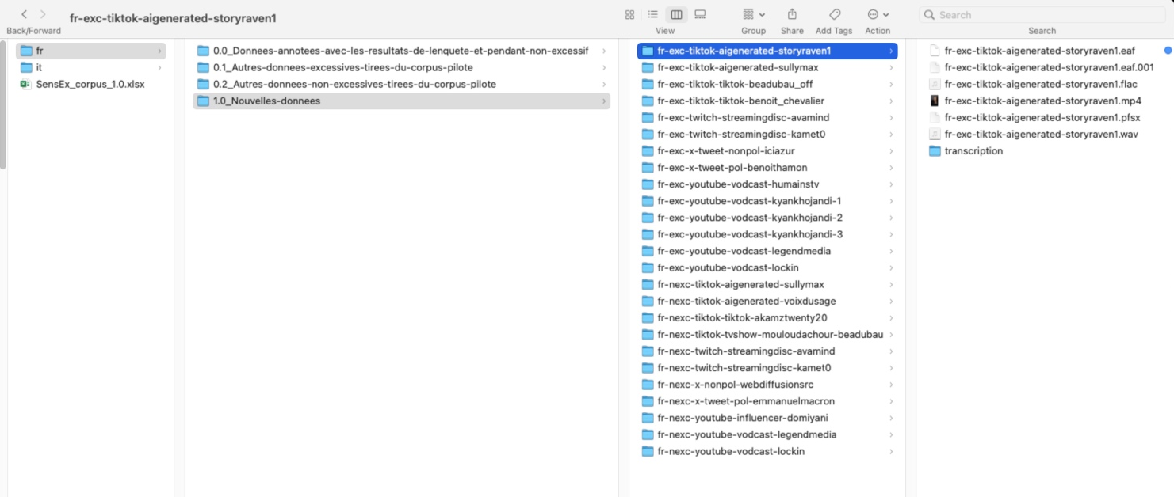

Data representation
Open the application ELAN, then click Ouvrir (‘Open’).
Select the _Corpus_Sens-Ex_1.0/fr/.
For illustration, let us take the fr-exc-youtube-comedic-artus-a.eaf located in the folder:
0.0_Donnees-annotees-avec-les-resultats-de-lenquete-et-pendant-non-excessif/
fr-exc-youtube-comedic-artus-a

You can also simply double-click fr-exc-youtube-comedic-artus-a.eaf to open it.
ELAN will open a window as shown below.
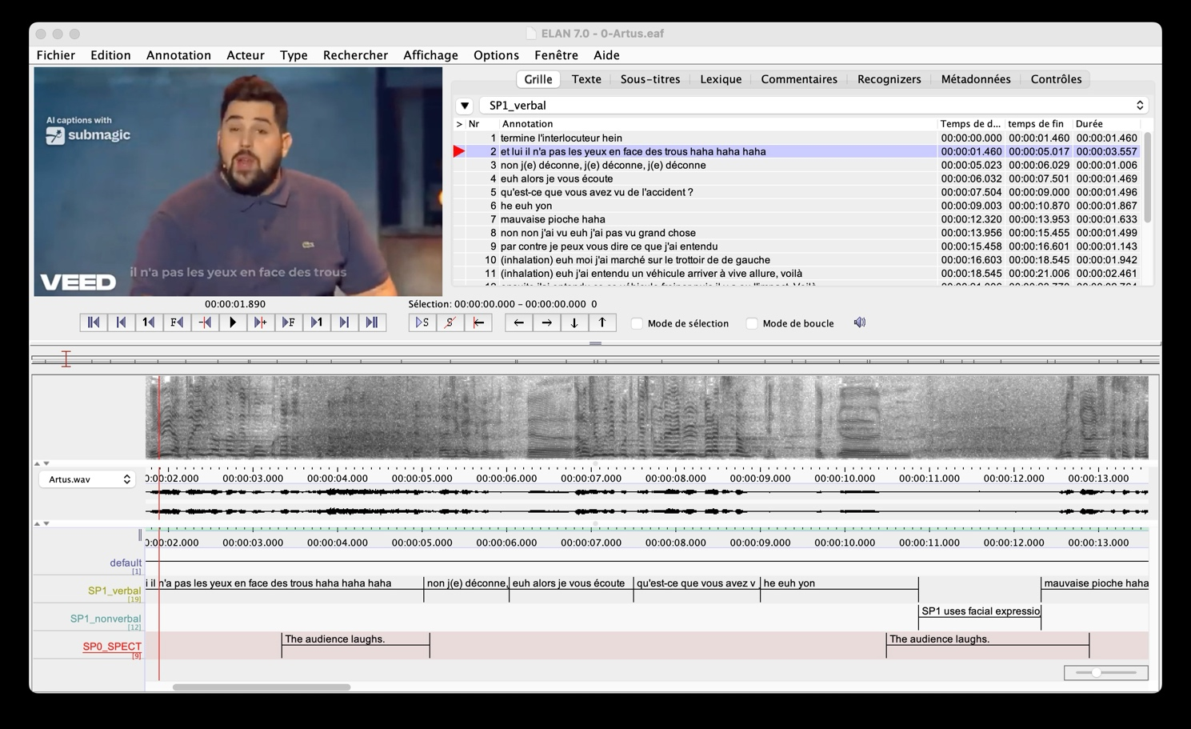

If you want to play the entire video, I recommend selecting the default tier and pressing the light-purple button. This helps avoid technical error that may occur when the playback continues beyond the actual duration of the video.

Tier name structure
Data representation in ELAN
- Segmentation of utterances (illocutionnary unit)
- Minimal orthographic transcription
- Three tiers per speaker:
  - SP_verbal
  - SP_nonverbal
  - SP_trs (transcription), subsequently derived from SP_verbal tier
- Optional tiers, depending on the type of stimulus:
  - SP0: SP0_SPEC, SP0_verbal, SP0_nonverbal
  - display: display_verbal, display_nonverbal
  - Userxxx: specific tiers related to interactional streaming discourse data; these correspond to anonymized Twitch user account names; this tier doesn’t follow the SensEx minimal orthographic transcription protocol, but it is automatically integrated from HTML transcript (regarding HTML transcript, see the section devoted to Twitch data extraction in the Tutorial for processing CMC multimedia data).

Speaker / source component
Every EAF file includes a basic transcription tier named “SP1_verbal”.
The segmented units in this tier target the sonorant audio signals and correspond to verbally materialized segments of the utterances. In other words, silent segments are not included in the SP1_verbal tier.
Tiers are added as a second or third speaker appears explicitly in the video: SP2_verbal, SP2_nonverbal, SP3_verbal, SP3_noverbal, and so on.
When the speaker cannot be clearly identified, the SP0 tier is used. This tier is mainly employed to annotate reactions from the audience. In the screenshot below, for example, the tier SP0_SPECT is selected, and the selected unit corresponds to “The audience laughs”.
If a speech unit is produced by an unidentifiable speaker, an SP0_verbal tier may be created.
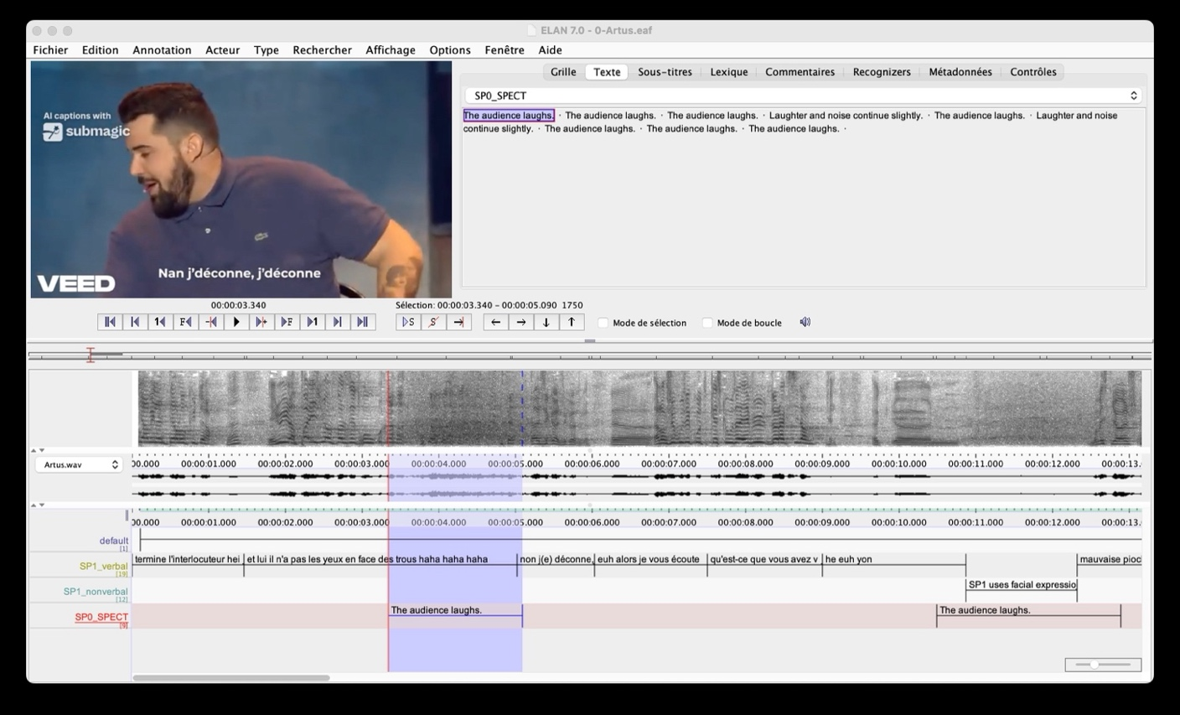

Transcription / description component

Tier _verbal

Illocutionary unit segmentation
Utterances are segmented into illocutionary units. The illocutionary unit is defined as:
“[...] the cohesion of sequences, Illocutionary Unit (henceforth IU) which are wrapped up into a unique illocutionary act, realising one and only one assertion, injunction, interrogation, etc. (Blanche-Benveniste et al., 1990; Berrendonner, 1990; Cresti, 2000; Deulofeu et al., 2010).
The text is thus segmented into IUs noted by // as in the following example:
ˆdonc quand vous arrivez sur la place de Verdun <+ la Préfecture est sur votre droite // vous < vous continuez tout droit // en fait <"euh" "ben" là <"euh" vous passez "euh" & // "ben" en fait < c’est la ligne du tram >toujours > là // [Rhap-M0001, Avanzi corpus]

Minimal orthographic trancription
The transcription follows a principle of minimal orthographic normalization. The objective is to produce a purely and minimally orthographic transcription in the _verbal and _trs tiers, in order to interfere as little as possible with subsequent syntactic parsing.

Purely orthographic means:
- No non-conventional forms meant to mimic spoken French/Italian (e.g. chavais, j’savais).
- Use standard spelling to ensure automatic processing.

Minimally orthographic means:
- Lowercase only.
- Tokens (words, numbers, acronyms, proper names) written in full letters.
- Word fragments (disfluencies, false starts) written in full letters in the _verbal tier.

Transcription protocol
- No capital letters for proper nouns or for the initial letter of a sentence;
- Names of alphabet letters must be written in letters: a, bé, cé, dé, e, effe, gé, ache, I, ji, ka, elle, emme, enne, o, pé, qu, erre, esse, té, u, vé, double vé, ixe, i grec, zèd
- No digit: numbers must be written in letters
- No punctuation marks such as: ? / ! / . / , / : / ;
- Orthographic transcription:
  - Conventionalised orthographic forms are preferred over spoken forms;
  - Example: [ʃavɛ pa] → je savais pas
    - not j’savais pas
    - not chavais pas
  - Exaggerated or expressive vowel lengthening is not marked. Prosodic analyses are carred out by phoneticians.
  - Disfluencies are transcribed including:
    - Word fragments (e.g., amorce de mot): je re re retrouve
    - Hesitations: euh
  - Rires are transcribed: ha ha

GAT2
Unintelligible syllables are marked following GAT2 convention: (xxx)
At this stage of data representation, the transcribed tiers (vocalized speech) are intended to be parsed automatically. Additional GAT2 conventions may be included later, notably for publication purposes.

Tier _nonverbal
Nonverbal communication cues are described in the “[speaker/source]_nonverbal” tier.
Two types of descriptions are made in this tier.
- Segments where the audio signal contains no verbal material but is likely to convey nonverbal meaning.
In the example below, the speaker “uses facial expressions and gestures to act as a visually impaired person.” To play the selected unit, select the annotation and press the light-purple play button 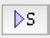.
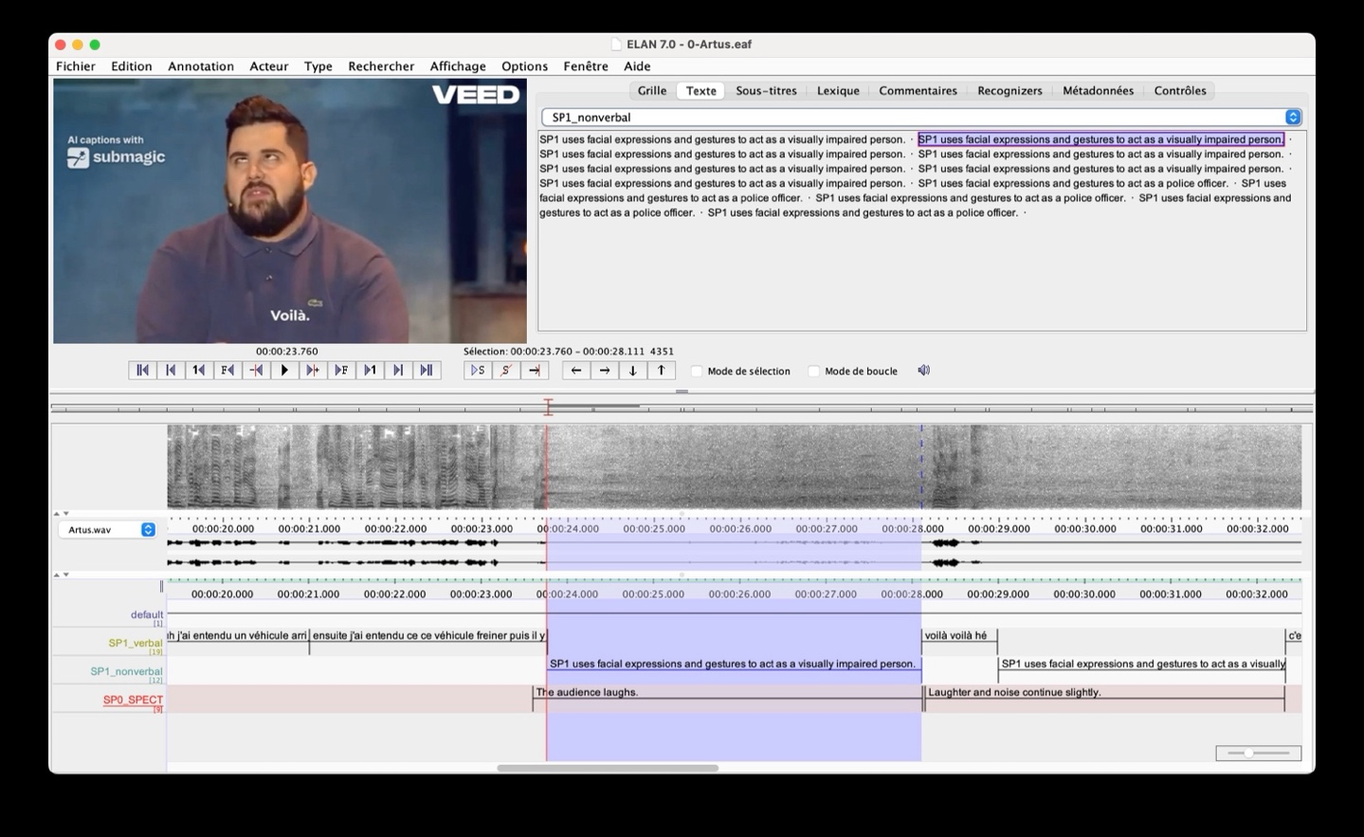

- Segments where the coverbal cues are intentionally produced by the speaker. The fr-exc-youtube-comedic-artus-a.eaf doesn’t contain this type of example.
In the fr-exc-youtube-comedic-ahmedsylla.eaf, we find an example of this type of nonverbal annotation: the speaker “does voice acting to imitate a feminine voice”.
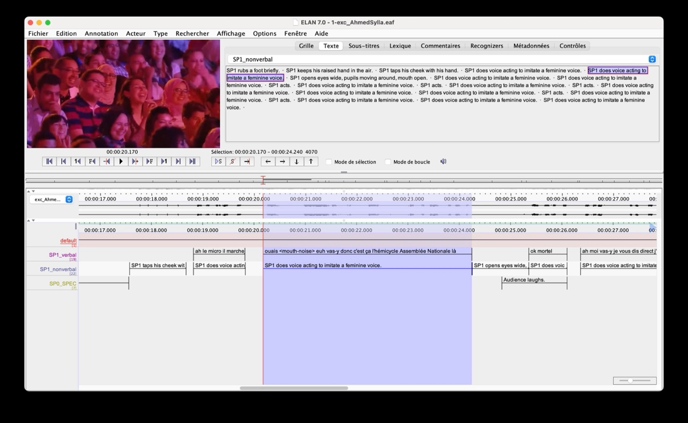

Tier _trs
The _trs tier corresponds to the tiers targeted for transcript export and is derived from the corresponding _verbal tier.
The difference between _verbal and _trs tiers lies in the inclusion of non-vocalized segments. The _verbal tier is designed to identify verbally materialized units and to determine whether nonverbal communication cues should be described. However, it does not include paralinguistic markups like pauses, mouth noises, or breathing sounds, especially at the beginning or end of an utterance. Therefore, the segments in the _trs tiers may extended to include adjacent paralinguistic material. In other words, the boundaries of the _verbal tier can be adjusted in the _trs tier so that the transcript reflects the full range of linguistic and paralinguistic phenomena.
For example, in fr-exc-youtub-influencer-maevaghennam-ext19sec.eaf, as illustrated below, the SP1_trs tiers is extended to include a paralinguistic markup such as aspired air.

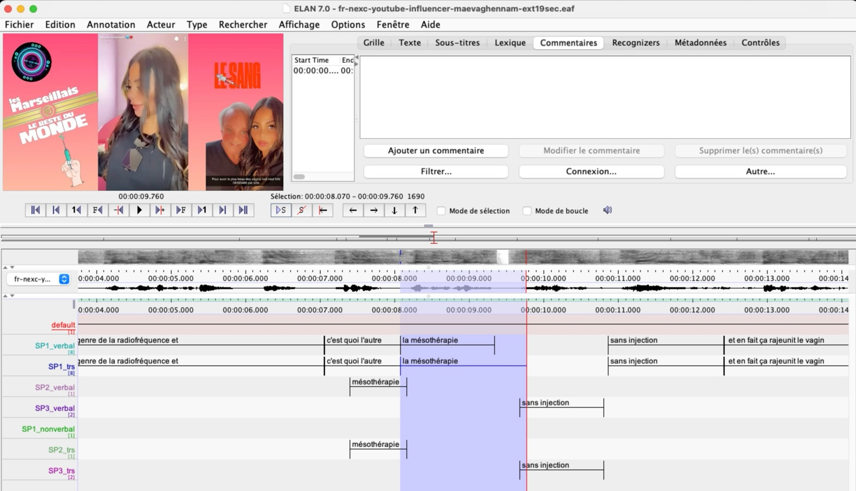

Creating a new annotation in ELAN

How to associate multimedia files
Click on the menu: Fichiers (‘Files’) > Nouveau… (‘New’). A window like the one below will appear.
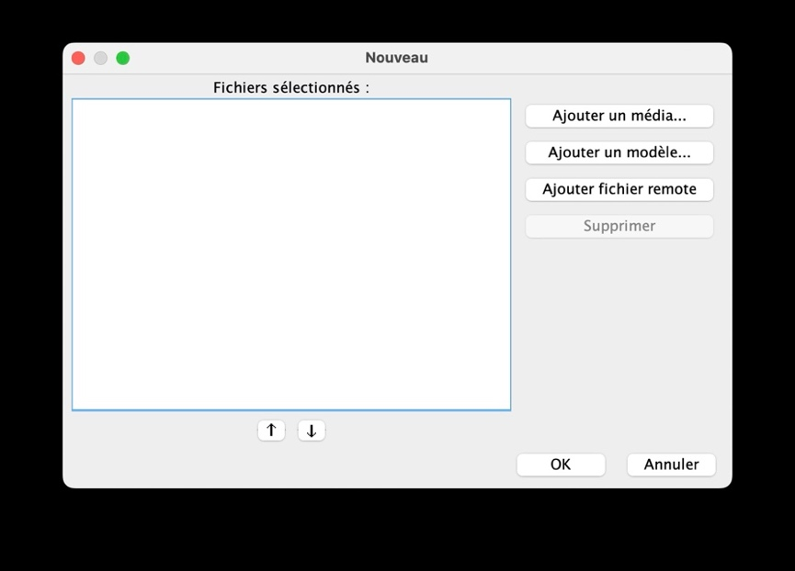
Click the button Ajouter un media… (‘Add a media’).
Select the directory where you stored the multimedia files you want to annotate. For illustration, let us take the fr-exc-youtube-influencer-tiboinshape.mp4 file, located in the _Corpus_SensEx_1.0/fr/0.0_Donnees-annotees-avec-les-resultats-de-lenquete-et-pendant-non-excessif/fr-exc-youtube-influencer-tiboinshape. You can add a complementary WAV file, doing the same process. Click the button Ajouter un media… again and select the fr-exc-youtube-influencer-tiboinshape.wav. With the WAV file, the audio signal and spectrogram will be loaded.
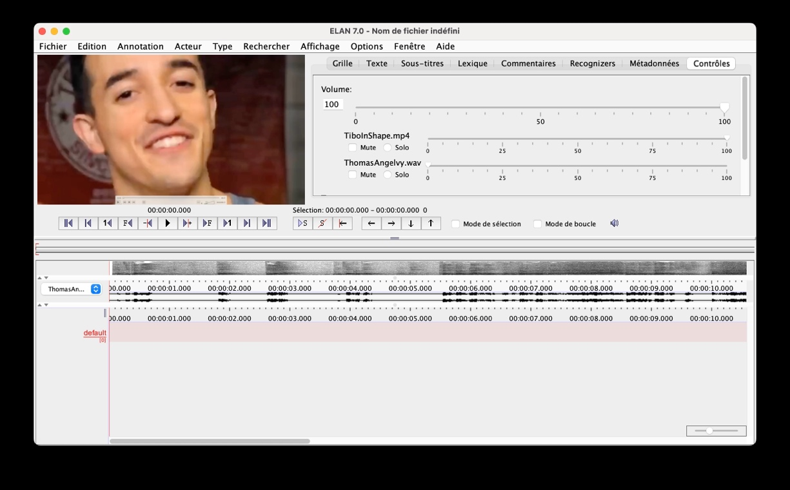
You can also add a supplementary multimedia file later by using Métadonnées (‘metadata’) in the function bar > Select Metadata Source.
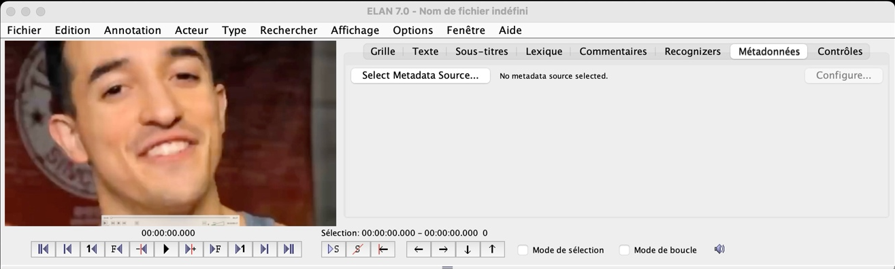
Once the multimedia files are correctly loaded, save the annotation file to create ELAN-related files. Make sure to select your correct working directory.

Check the location of the multimedia files
Check the display mode in the function bar: Métadonnées > click the button Select Média liés ‘Select linked media’ > then click on Fichiers média liés ‘Linked media files’.
In the example below, the wrong WAV file was selected. You can delete it (select the incorrect file and press Supprimer ‘delete’ button) and add the correct one (press the Ajouter… and select the approriate media file).
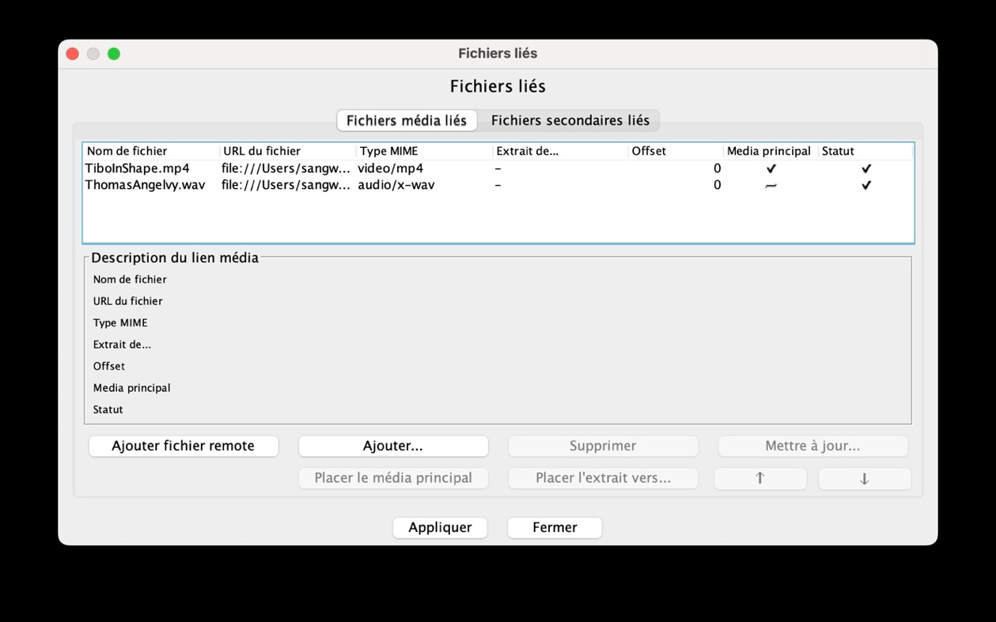

Check the display mode
Check the display mode in the menu: Affichage ‘Display’ > Viewer. If a viewer is selected but not functioning properly, simply deselect it and then reselect it.
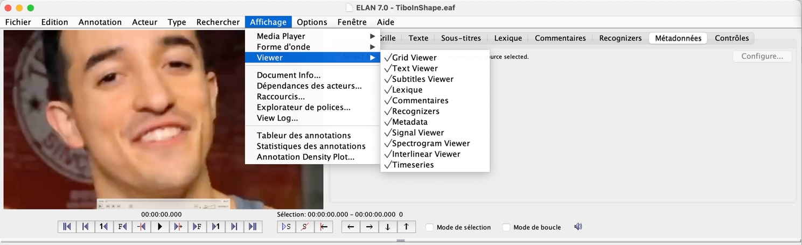

Different modes
The data of the pilote corpus were transcribed and segmented in Annotation mode. To check the current mode, go to the menu: Options > Mode d’annotation ‘Annotation mode’ is checked.
Please note that ELAN interface offers four additional modes: Mode Synchronization de média (‘Media Synchronization Mode’), Transcription Mode, Segmentation Mode, and Interlinearization Mode.

How to add a new tier
Go to the menu: Acteur (‘Actor’), select Ajouter nouvel acteur… ‘Add new actor’. A window like the one below will appear. Name the actor: SP1_verbal, for example.
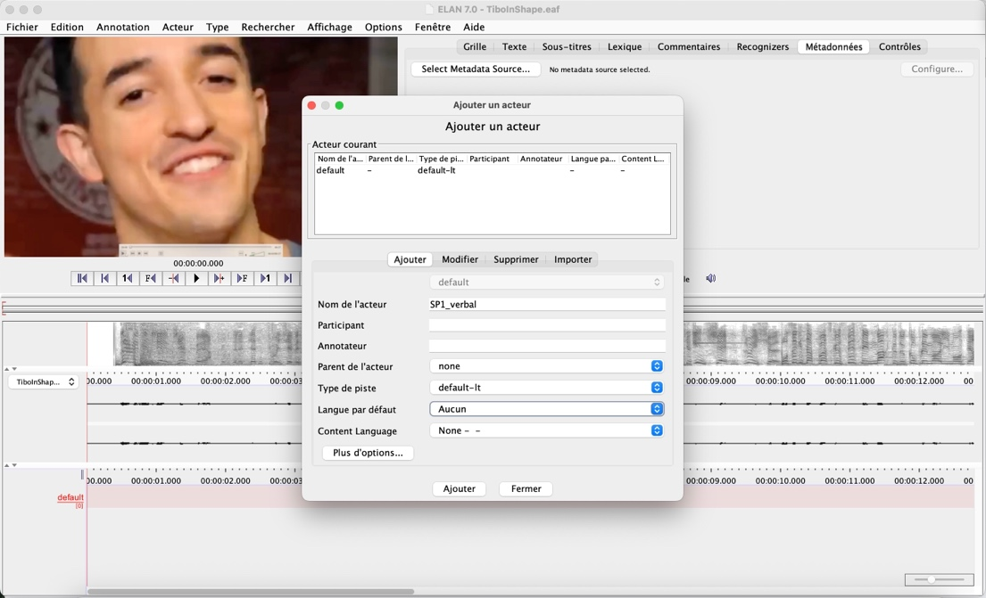

Add an annotation
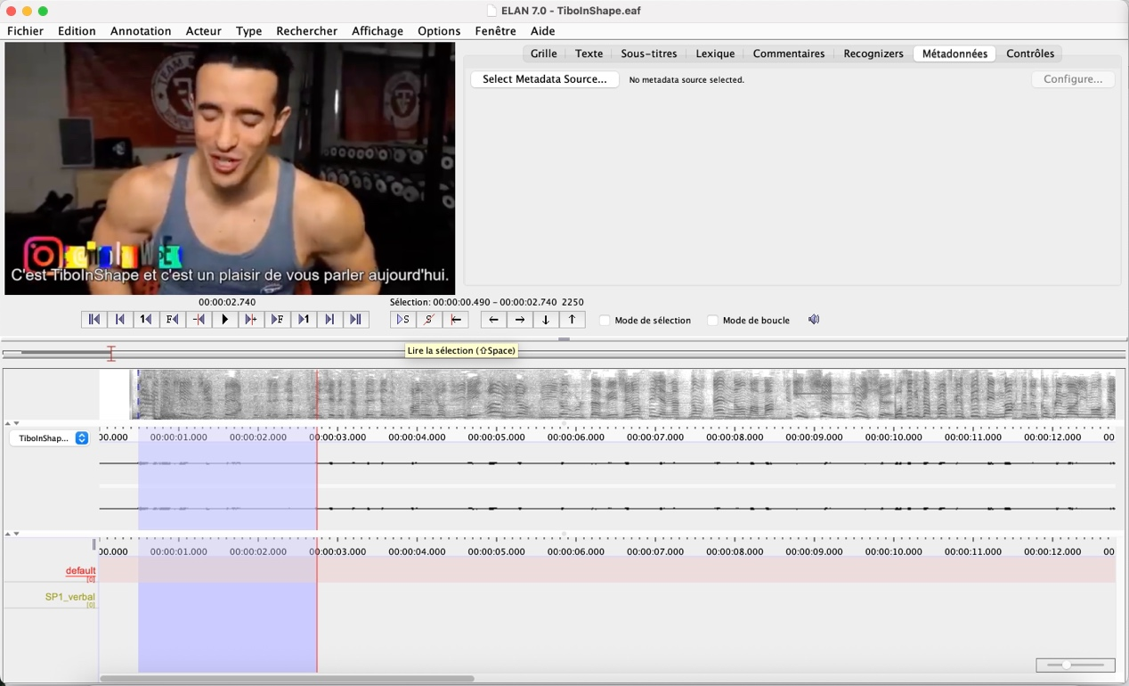
You can see the new tier “SP1_verbal”. Using the curser, drag over the segment you want to choose, then right-click and select Nouvelle annotation ici ‘New annotation here’, or simply double-click. Type the text.
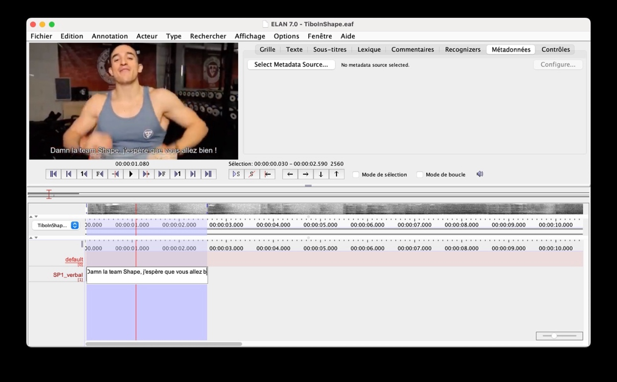
To adjust the start or the end point of a segment, use the curser. Place the curser near the start or end boundary and hold the Option key (Mac) or Shift key (Windows). The curser will change shape to indicate that the boundary can be moved.
If you place the curser in the middle of the segment, click, and hold the Option key or Shift key, you can move the entire segment to the right or left.
You can also edit the exact timecode manually. Select the segment, right-click, and choose Modify annotation time. You will also find other useful functions in the menu that appears when you right-click on a segment.
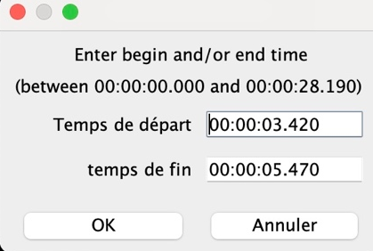

Function bar: Grille, Texte, Commentaires
Two places are useful to know.
To the right of the video frame, you will see the function bar, starting with Grille (‘grid’).
Select the Texte (‘text’) and choose the tier whose textual content you want to display at a glance – SP1_verbal for example – as shown below.
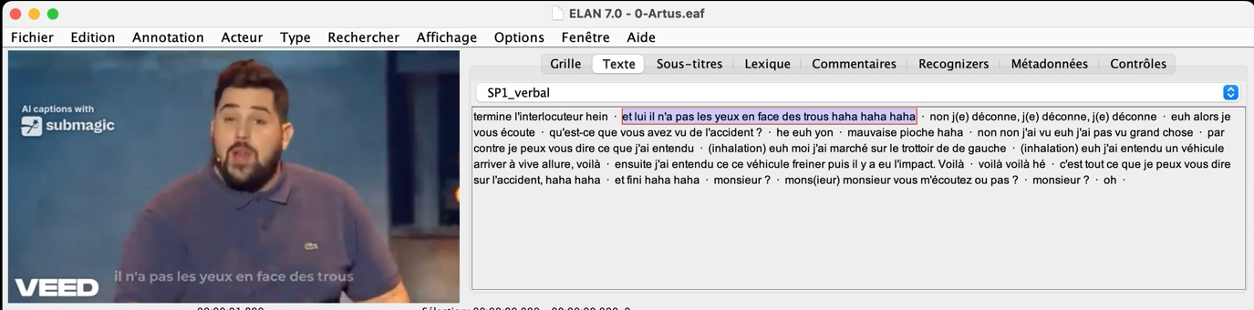

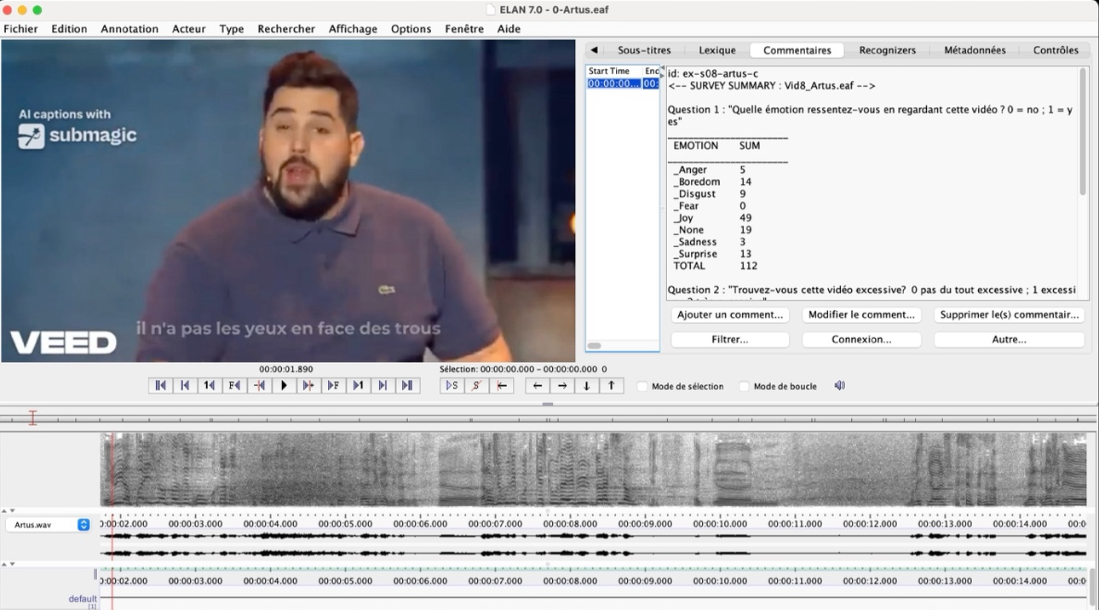
For the 10 stimuli that were included in the survey, the respondent’s answers are displayed in Commentaires. Make sure to click on the corresponding time span first to make them visible. The comment is stored in the default tier.
The screenshot above shows the comment window displaying the results of the first survey question: “What emotion do you feel regarding this video? 0= no; 1=yes”. The table summarizes the total scores for each emotion: _Anger, _Boredom, _Disgust, _Joy, _None, _Sadness, _Surprise, and TOTAL.
The screenshot below shows the second part of the comment window displaying the second survey question: “Do you find this video excessive? 0 non excessive at all; 1 excessive; 2 very excessive”. The table summarizes the total scores, the number of answers and the mean score for each evaluated domain of excessiveness: _Discourse, _Facial, _Gestures, _Global, _Other, _Speed, _Subject (topic), _Tone, _TrunTaking, _Voice, _Words, and TOTAL.
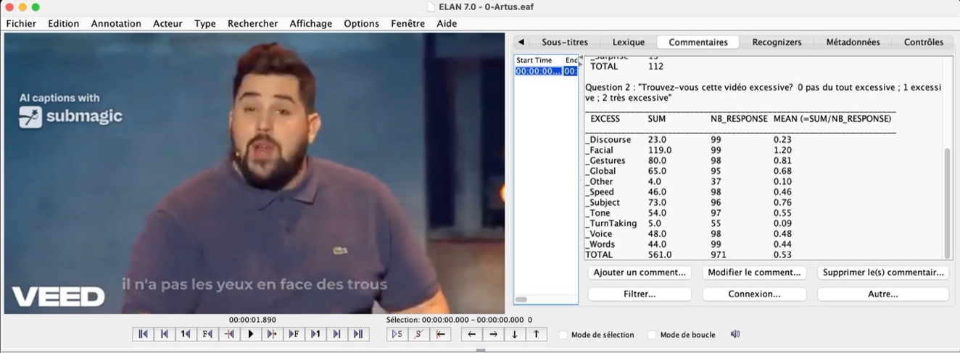

Exporting transcripts
On the Menu: Fichier “File” > Exporter vers… “Export to…” > Transcription de texte traditionnel “Traditional text transcription”.
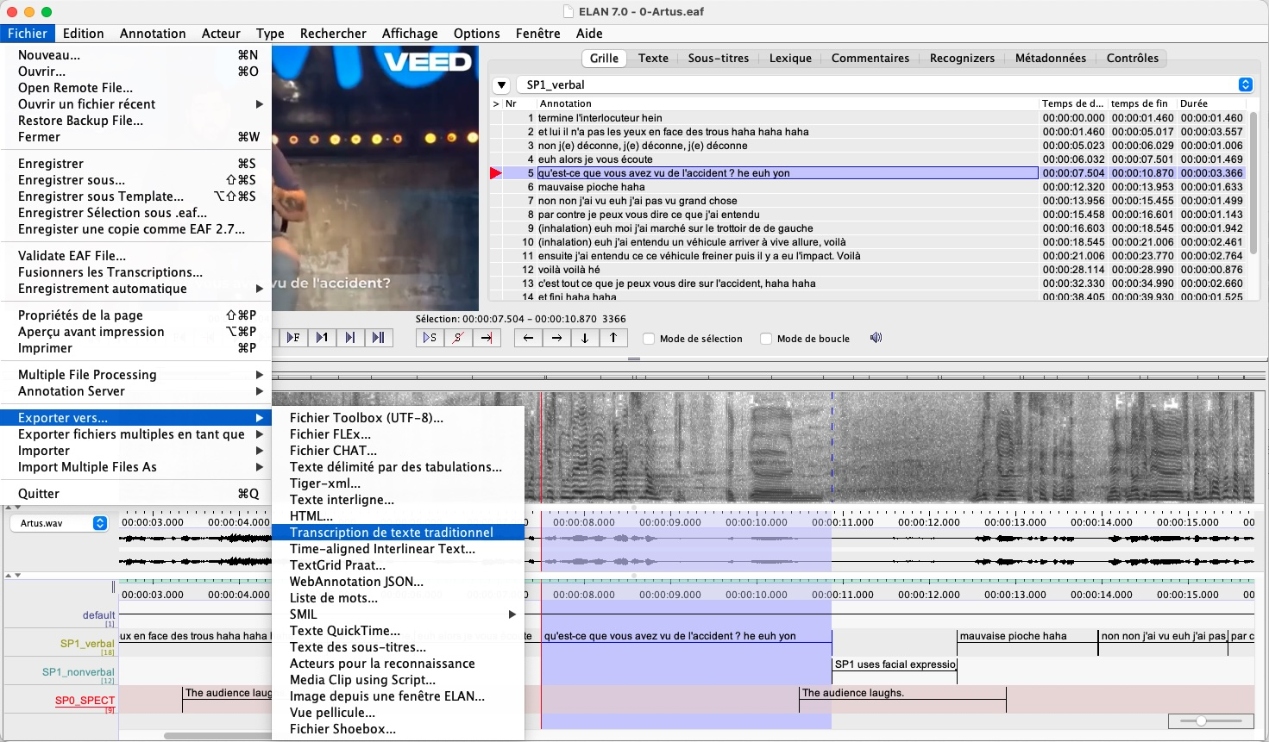

Select the tiers and criteria you want to export to a texte file.
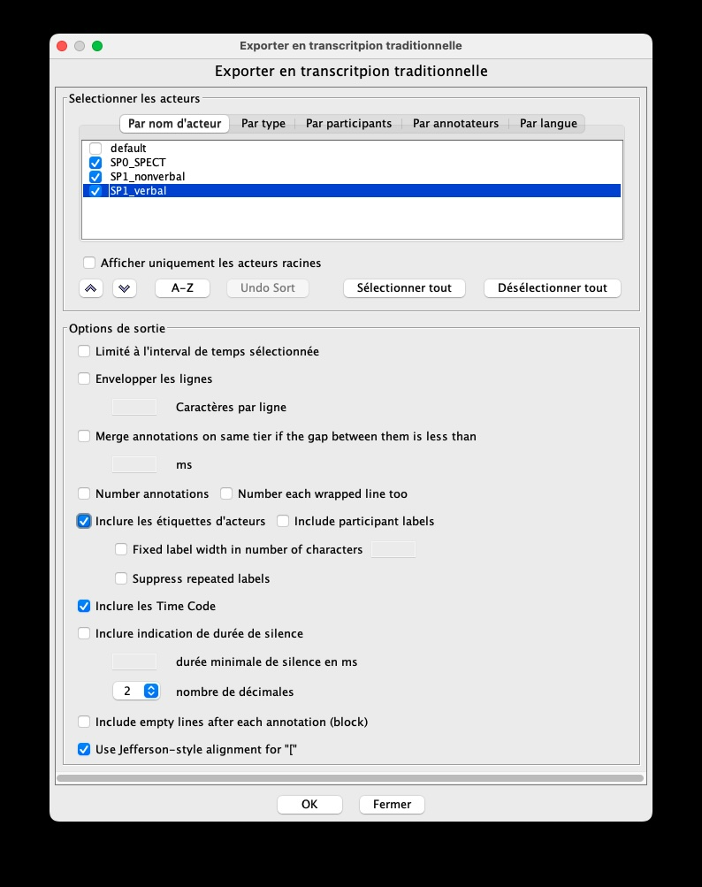
Please do not choose the option to use Jefferson-style alignment for “[”, which will generate a formatted transcript. The square bracket indicates overlapping speech between speakers.

Open selected segments in Praat
Praat must be installed beforehand in your working environment.
Right-click on the selected signal and choose “Ouvrir Sélection dans Praat” (Open selection in Praat). The first time, a directory window will appear and ELAN will ask you to Locate the Praat executable “Localizer l’exécutable Praat”. Navigate to the folder where Praat is stored and select the executable file.
After this initial step, right-clicking a selected audio signal will automatically open to open the segment in the Praat interface.
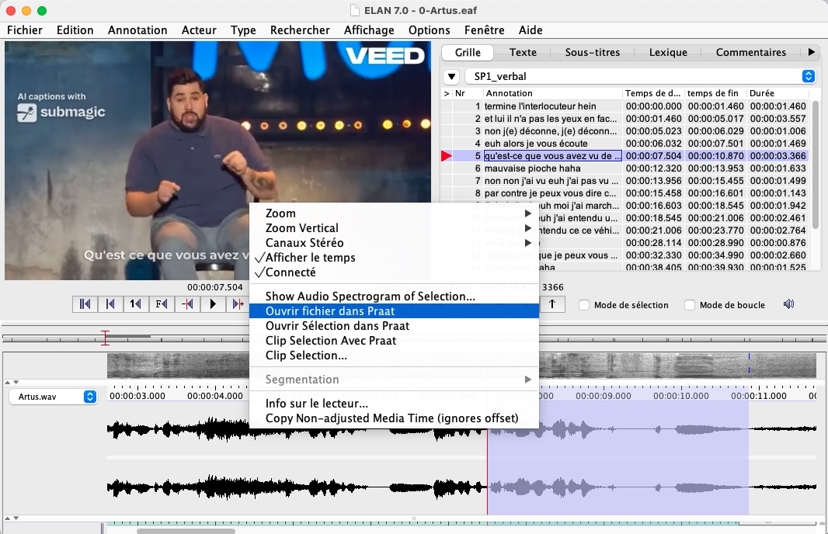

How to run queries
On the Menu: Rechercher > Recherche structurée de plusieurs eaf…
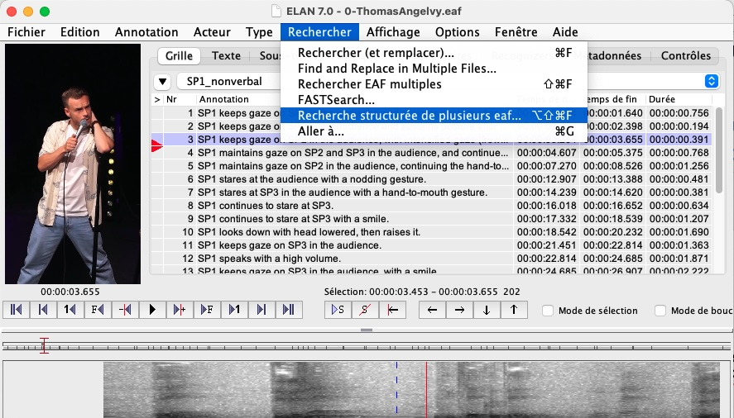

Click on Multiple Layer Search
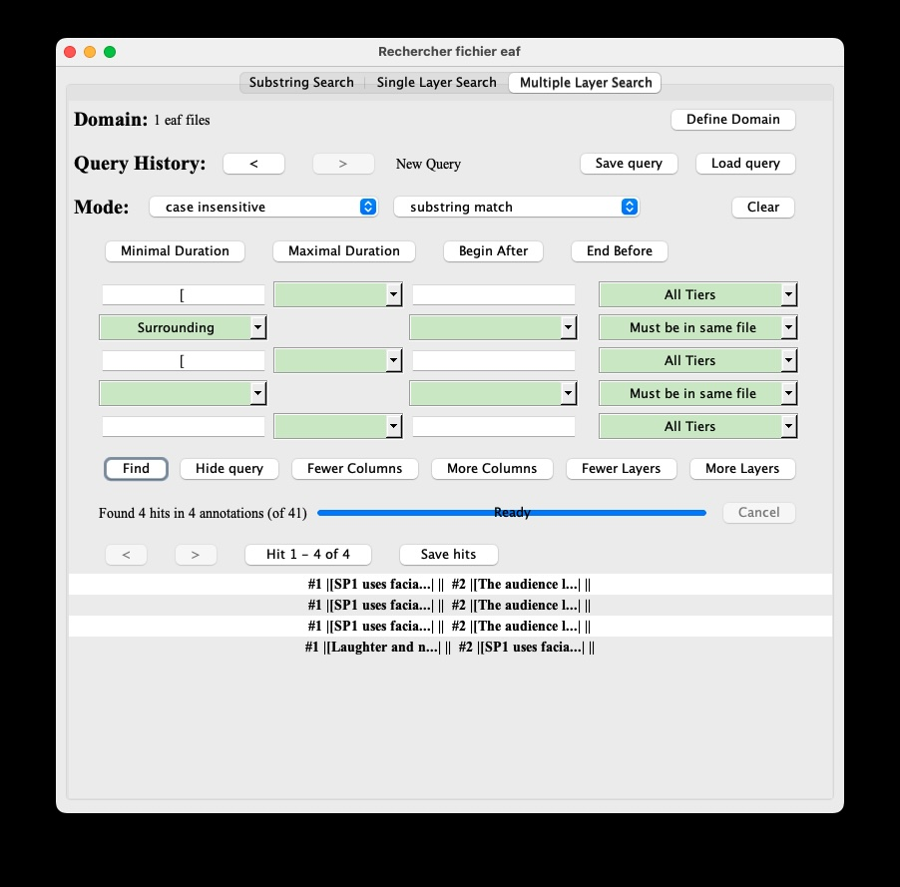

“Sens-Ex – Sensationalism and discursive excess in the post-digital era (structuring project of the Maison Européenne des Sciences de l’Homme et de la Société Lille Nord de France, 2025–2027) aims to identify the formal features that characterize sensationalist discourse across a wide range of discursive genres” https://olindinum.huma-num.fr/recherches/projets-de-recherche/

